Battleship User Manual

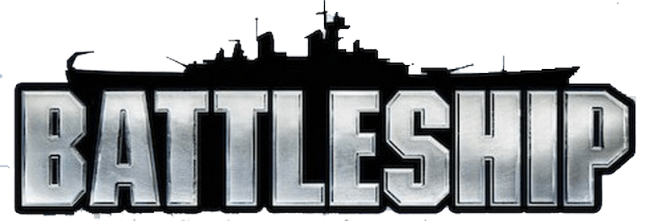

A game by Logan Price

Manual written by Logan Price

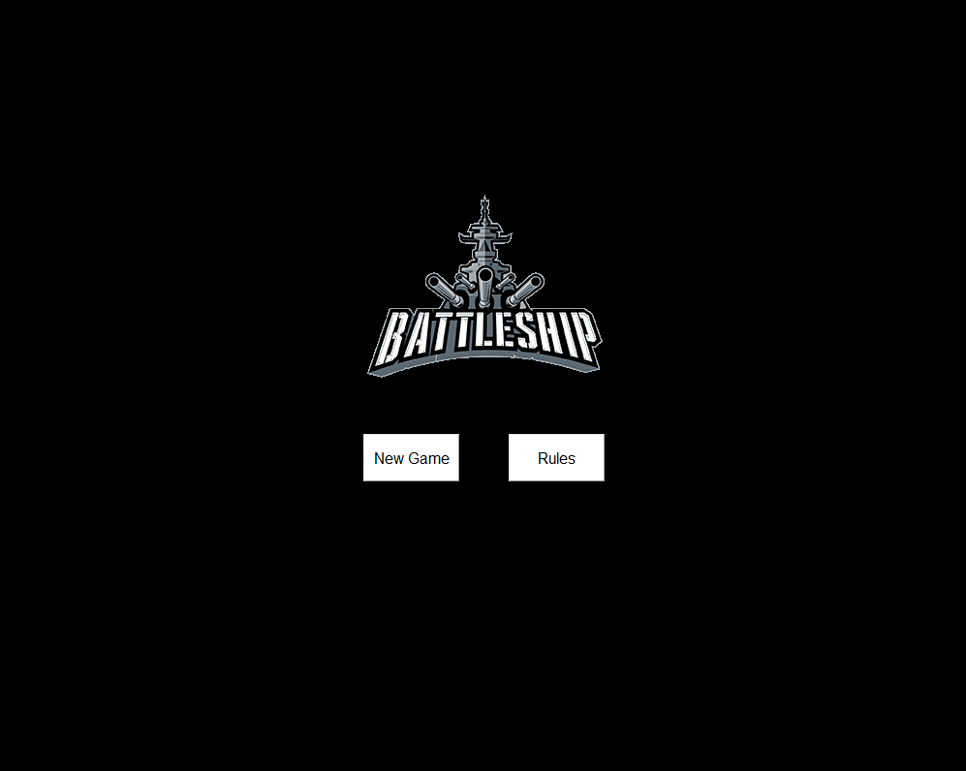

Main Menu

When launching the Battleship Game application, you will be greeted with the above screen. From this screen, you may click on the New Game button or the Rules button. For the Rules button go to page 3, or for the New Game button page 4.

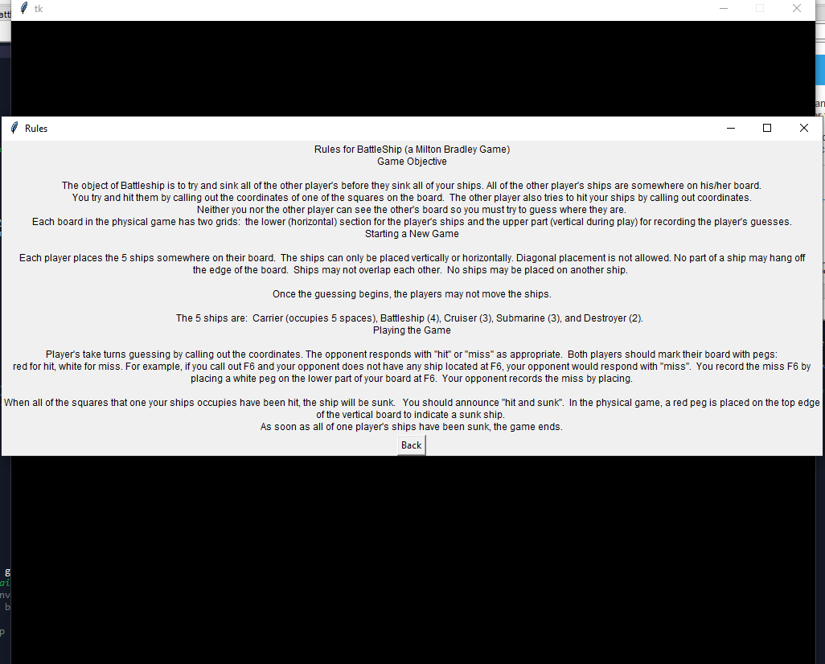

Rules

Upon clicking the Rules button on the Main Menu a new window is opened that displays the rules for the game as written by Milton Bradley. This window can be closed by clicking the X in the top right or by clicking the Back button.

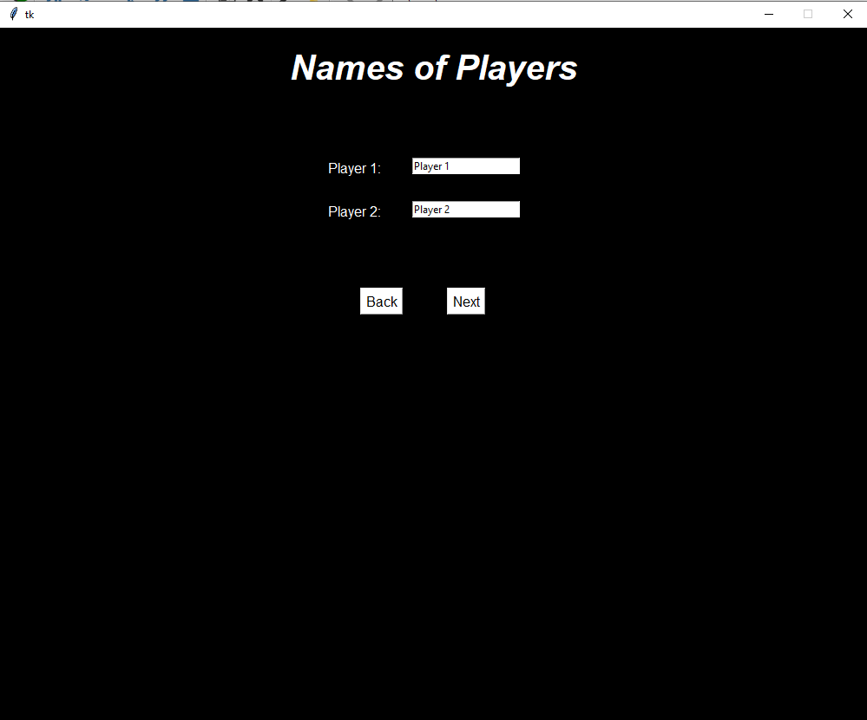

Player Names

Upon clicking on the New Game button, you will be taken to the Player Name screen. On this screen you will be prompted to input the names of both players, which they will be referred to in the game. Clicking the back button will take you back to the Main Menu and clicking Next will take you to the next screen, the Ship Setup screen for the first player. At this point the second player should not be able to see the screen, but it is up to the first player to make sure of this.

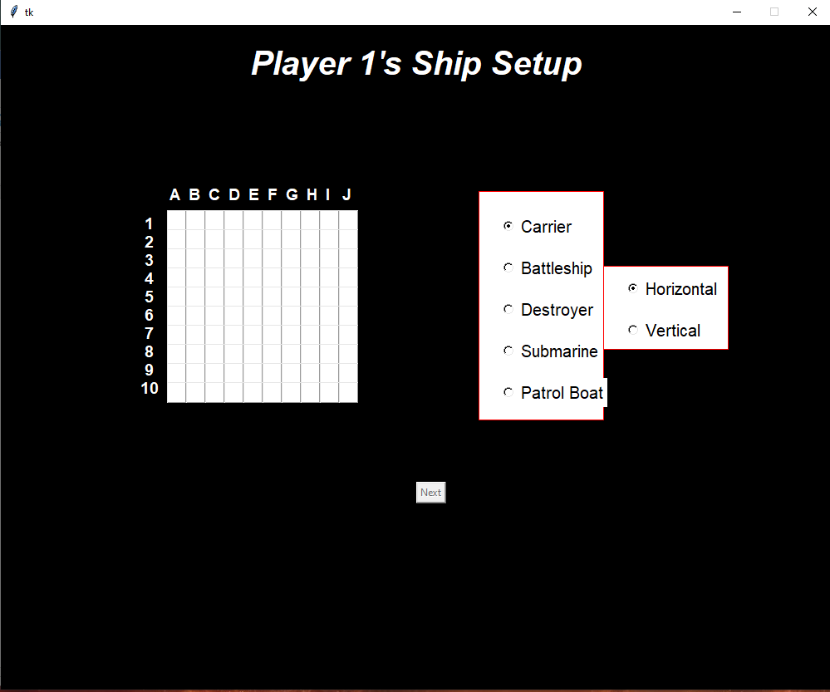

Ship Setup pt. 1

Once you get to this screen, the game has begun. To the left is the grid that your ships will appear on, but at first they will be blank. To the right are the options for the ship placement. The first set of options are for selecting which ship you wish to place, and the second is for the orientation of the ship. Notice that the Next button is currently disabled at this point. It will be enabled once setup has been completed.

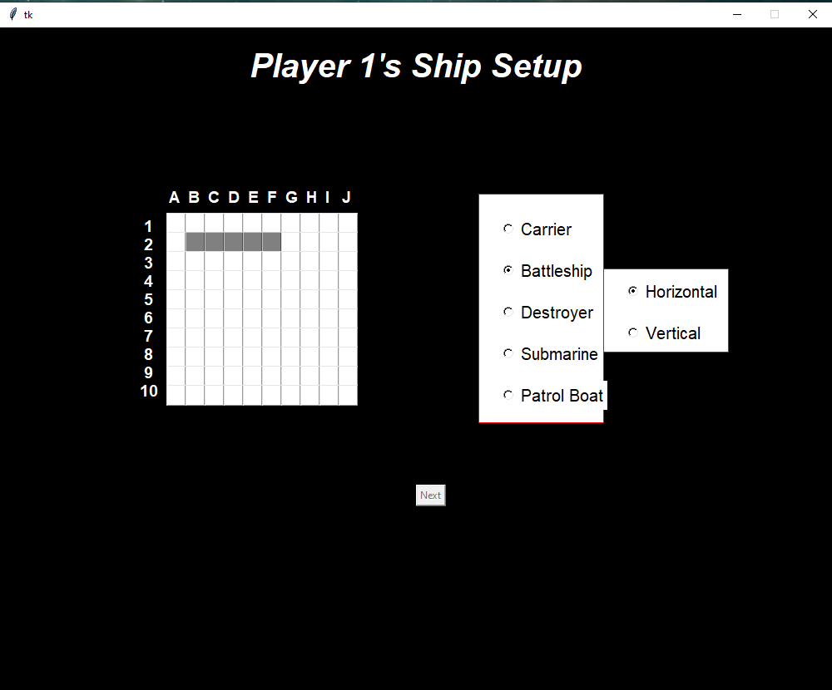

Ship Setup pt. 2

In the example above, the player clicked square B2 with the options Carrier and Horizontal. Upon clicking this square, the ship’s top left most square is placed there. The carrier is 5 squares long and since it is set to horizontal, square B2, C2, D2, E2, and F2 are covered by this ship. If vertical was instead selected, positions B2, B3, B4, B5, and B6 would be covered instead. After this ship has been placed, the next ship (the Battleship in this case) is automatically selected to make setup take less clicks. Note that any illegal ship placements will be met with a popup informing that an illegal placement was attempted.

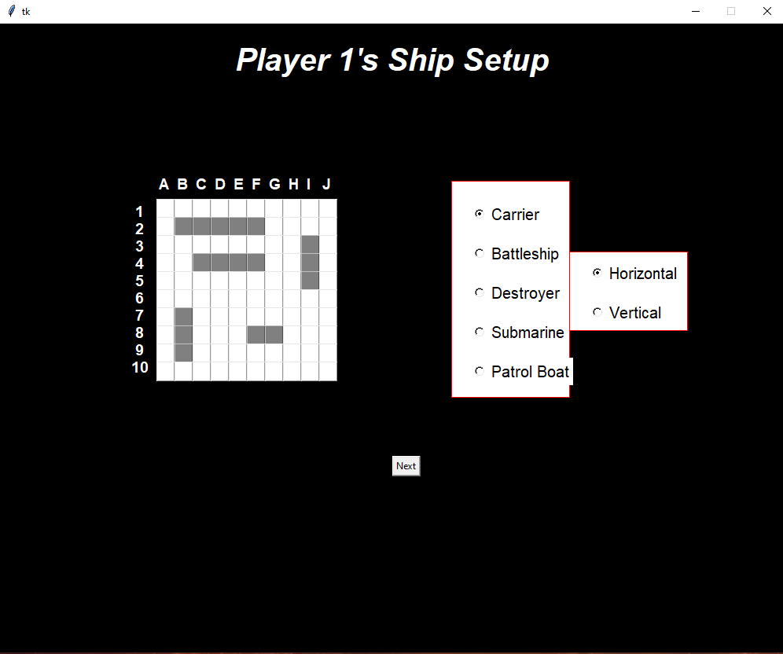

Ship Setup pt. 3

In this picture, all of the ships have been placed, and the Next button is now enabled

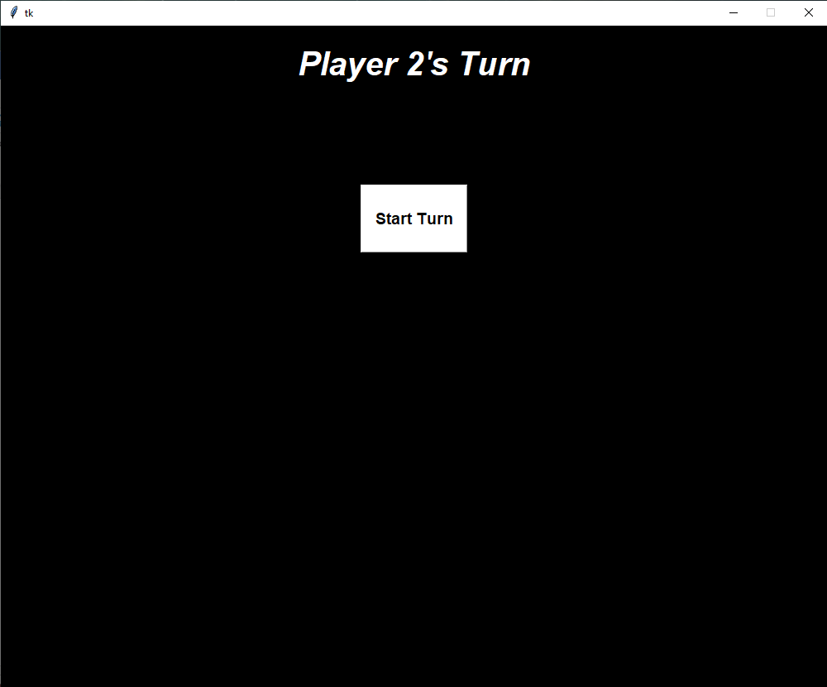

Intermediate

After completing the setup and clicking the Next button, you will be taken to the intermediate screen. When you see this screen, it means that it is the next player’s turn. The current player should leave and not be able to see the screen once they reach this point, and the other player takes their spot and clicked the Start Turn button. The second player will then do the same as player 1, and place their ships, then be taken to this screen. Player’s will also see this screen after their turns so they cannot see their opponent’s ship locations.

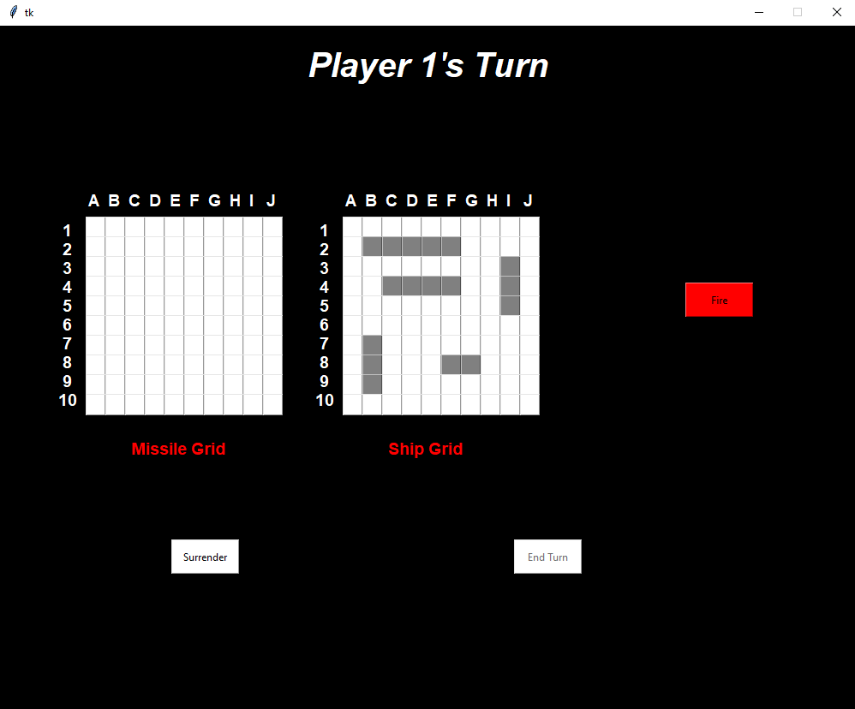

Turn pt. 1

In this picture, we have player 1’s first turn. To the left we see player 1’s missile grid, to the right of that player 1’s ship grid, ad even farther right is the Fire button. There are also Surrender and End Turn buttons, the latter currently disabled since no missile has been fired yet. On this screen, the player wants to click a square on the missile grid and then click the fire button. The player can also click the Surrender button if they want to forfeit the game, taking the game to the Game Over screen (page 12). In this scenario, the player will have clicked on square G5 and then the Fire button. (cont.)

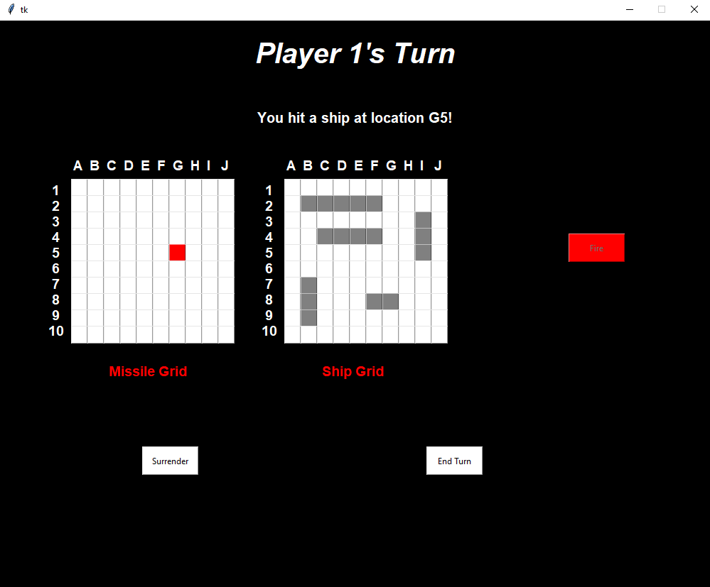

Turn pt. 2

The above picture is what is displayed after clicking the fire button. You will notice that quite a few things have happened. Firstly, there is now a message above the grids stating what has occurred from the missile firing. Secondly, a square has been colored red on our the missile grid. Since we hit the ship, the color is red. Additionally, the Fire button is now disabled and the End Turn button is now enabled. Clicking the End Turn button now will take us to the Intermediate Screen (page 8) and the opponent will begin their turn.

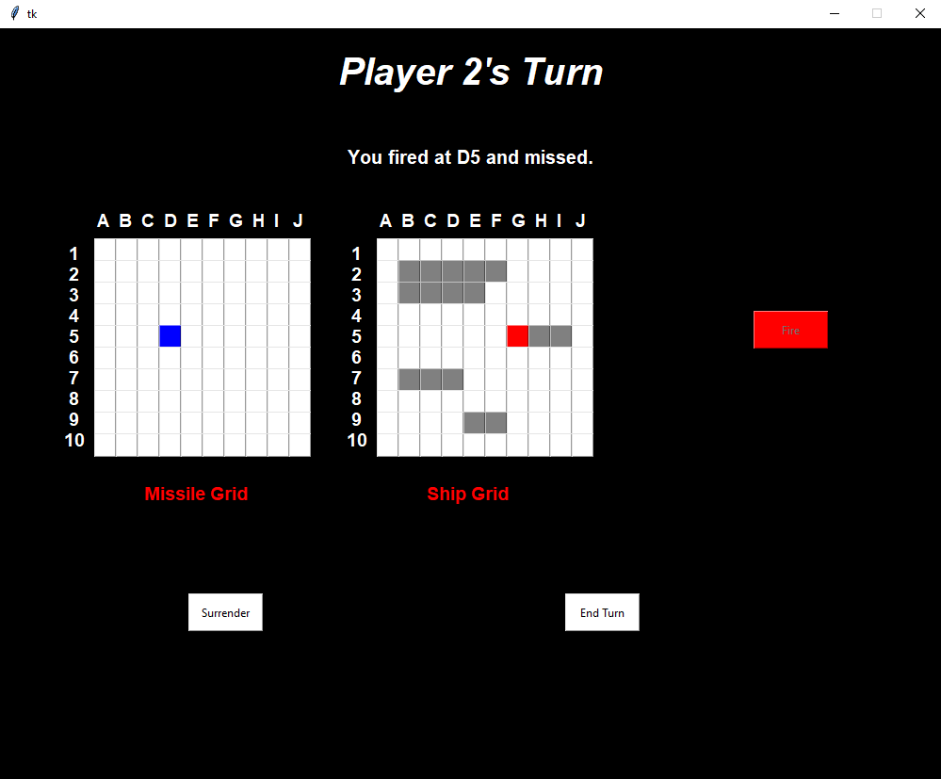

Turn pt. 3

In the image above, we have another scenario in which the fired missile was a miss. As displayed, a missed missile will be displayed as blue, and our opponent’s missile now appear on our ship grid. Also note that after the first turn, the turn will start with a message telling what the opponent did on their last turn.

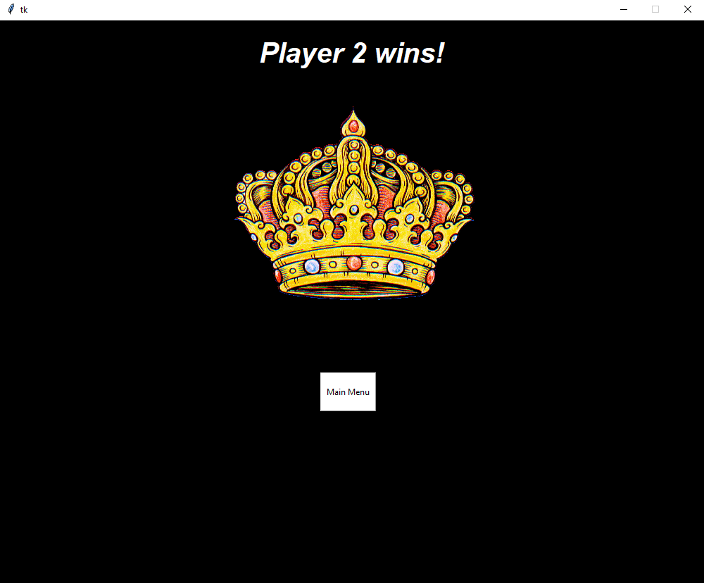

Game Over

This is the final screen in the game, which displays the winner of the game, either by sinking all ships or forfeit. The Main Menu button can be clicked, which will take you back to the main menu.